Sign Up

**77 Library**

Login

Search

**Terms of Use:**

77Library eBooks may be freely used in Singapore because most are not protected by Singapore copyright law. They may not be free of copyright in other countries. Readers outside of Singapore must check the copyright terms of their countries before accessing, downloading or redistributing eBooks. We also have a number of copyrighted titles, for which the copyright holder has given permission for unlimited non-commercial worldwide use.

The 77Library website is for human users only. Use of automated tools to access the website may trigger a block of your access. This site utilizes cookies, captchas and related technologies to help assure the site is maximally available for human users. See full terms of use [here](https://www.gutenberg.org/policy/terms_of_use.html).

Science Fiction

Romance

Fantasy

**No fee or registration!** Everything from Sky Library is completely without cost to readers. If you find 77Library useful, please consider a small donation to help 77Library digitize more books, maintain its online presence, and improve 77Library programs and offerings. Other ways to help include digitizing, proofreading and formatting, or reporting errors.

Recently Returned

Book name

Author

Availability

Book name

Author

Availability

Book name

Author

Availability

  

About 77Library

Privacy policy

Terms of use

Donations

Contact Us

Tables:

Book: BookID, BookName, Author, Genre, Publisher, Pages, Availability

Author: AuthorID, AuthorName

Members: MemberID, FirstName, LastName, Address, ContactNum, Email

Transactions: TransactionID, MemberID, BookID, BorrowedDate, ReturnDate, Fine

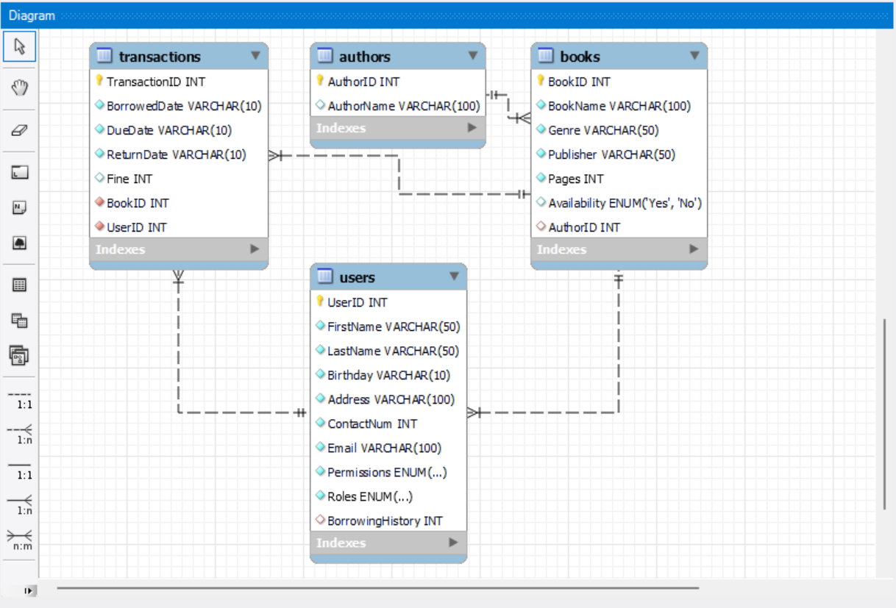

Author, book name, genre, publisher, pages

Jenny Han, P.S. I Still Love You, Romance, [Simon & Schuster BFYR](https://openlibrary.org/publishers/Simon_&_Schuster_BFYR), 352

Diana Palmer, Weddings in White: Three Complete Novels, Romance, Silhouette, 410

Rexanne Becnel, The Knight of Rosecliffe, Romance, [St. Martin's Paperbacks](https://openlibrary.org/publishers/St._Martin's_Paperbacks), 336

Jacqueline Wilson, The bed and breakfast star, Kids, [Yearling](https://openlibrary.org/publishers/Yearling), [RANDOM HOUSE CHILDRE](https://openlibrary.org/publishers/RANDOM_HOUSE_CHILDRE), 208

J. K. Rowling, Harry Potter and the Sorcerer’s Stone, Kids, [Scholastic](https://openlibrary.org/publishers/Scholastic), 309

Laura Amy Schlitz, The Hired Girl, Kids, [Candlewick Press](https://openlibrary.org/publishers/Candlewick_Press), 392

Stephen King, The Bachman Books, Thriller, [New American Library](https://openlibrary.org/publishers/New_American_Library), 923

Clive Cussler, Treasure, Thriller, [Pocket Books](https://openlibrary.org/publishers/Pocket_Books), [Pocket](https://openlibrary.org/publishers/Pocket), 547

Stephen King, Wolves of the Calla, Thriller, [Donald M. Grant](https://openlibrary.org/publishers/Donald_M._Grant), 714

CREATE TRIGGER `issue_book` BEFORE INSERT ON `book_issue`

FOR EACH ROW BEGIN

SET NEW.due_date = DATE_ADD(CURRENT_DATE, INTERVAL 20 DAY);

UPDATE member SET balance = balance - (SELECT price FROM book WHERE

isbn = NEW.book_isbn) WHERE username = NEW.member;

UPDATE book SET copies = copies - 1 WHERE isbn = NEW.book_isbn;

DELETE FROM pending_book_requests WHERE member = NEW.member AND book_isbn = NEW.book_isbn;

END

CREATE TRIGGER `return_book` BEFORE DELETE ON `book_issue`

FOR EACH ROW BEGIN

UPDATE member SET balance = balance + (SELECT price FROM book WHERE isbn = OLD.book_isbn) WHERE username = OLD.member;

UPDATE book SET copies = copies + 1 WHERE isbn = OLD.book_isbn;

END

Deploy application on Heroku

https://spring.io/guides/gs/rest-service/https://spring.io/guides/gs/serving-web-content/https://spring.io/guides/tutorials/rest/